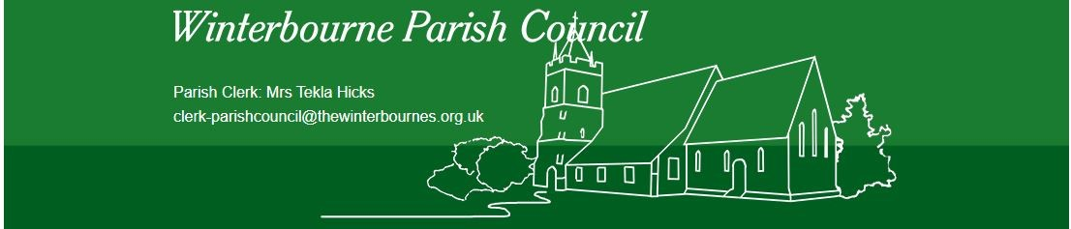

Notice is hereby given of the Annual Parish Meeting to be held on Thursday 27th March 2025 at 7.00pm to transact the following business at the location of the Glebe Hall, Winterbourne Earls, Salisbury, Wiltshire SP4 6HA.

C. Penn

Cllr C. Penn,

Chair

AGENDA

No. | Item
1. | Welcome and Apologies  To receive and accept apologies for those unable to attend.
2. | Minutes of the Previous Meeting  To approve and adopt the minutes of the meeting held on 14th March 2024.
3. | Parish Matters  An opportunity for members of the electorate to raise matters.
4. | Chair’s Report  To receive updates from the parish council.
5. | Village Reports  An opportunity for invited village groups to present their report to the meeting.
6. | Public Forum  Am opportunity for members of the public to ask questions.
7. | To close the meeting

